What is generative AI?
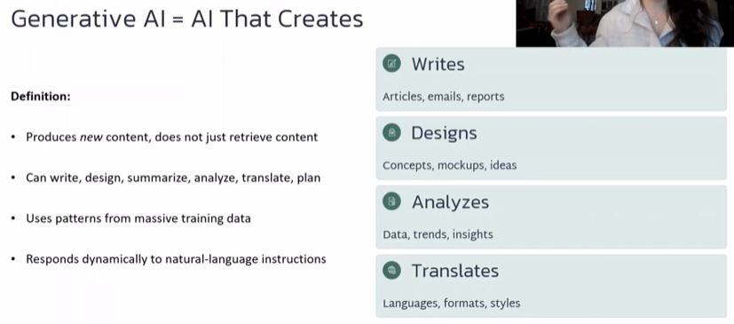
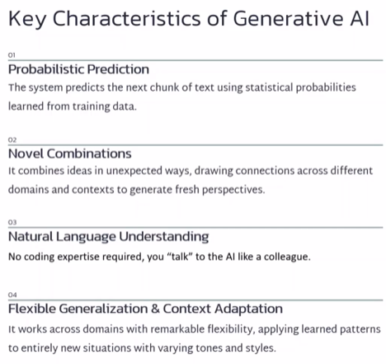
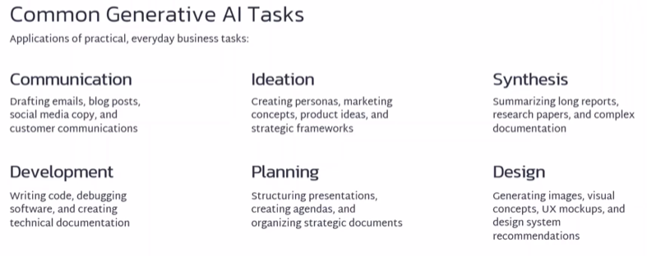
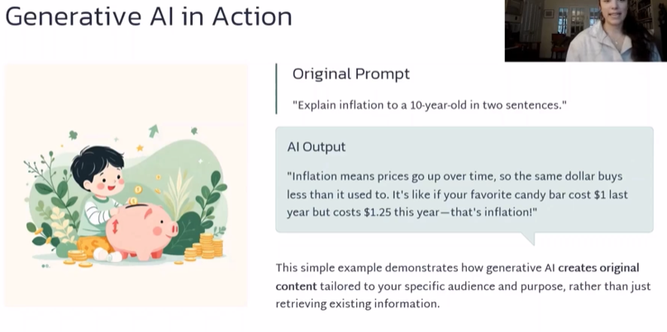
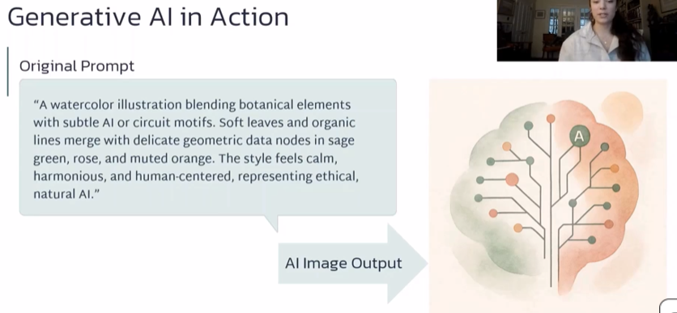
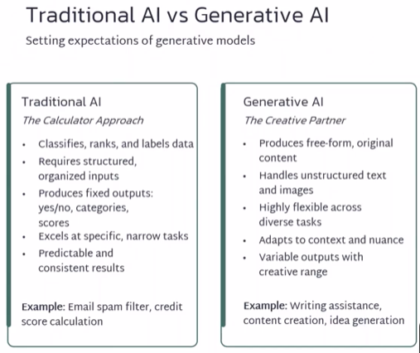
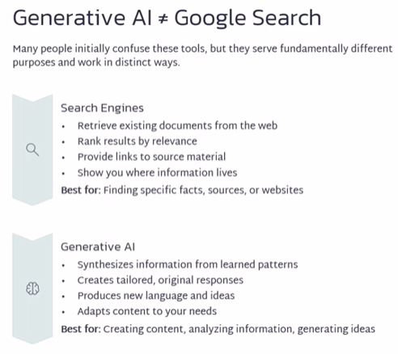
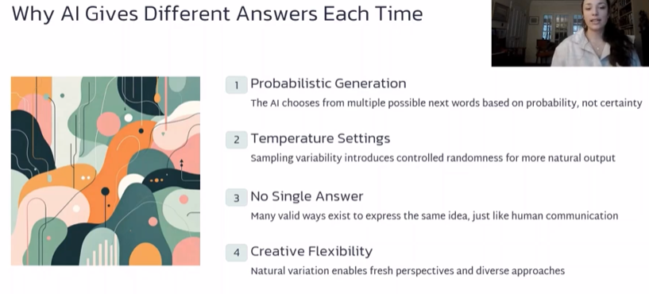
Hese limitations 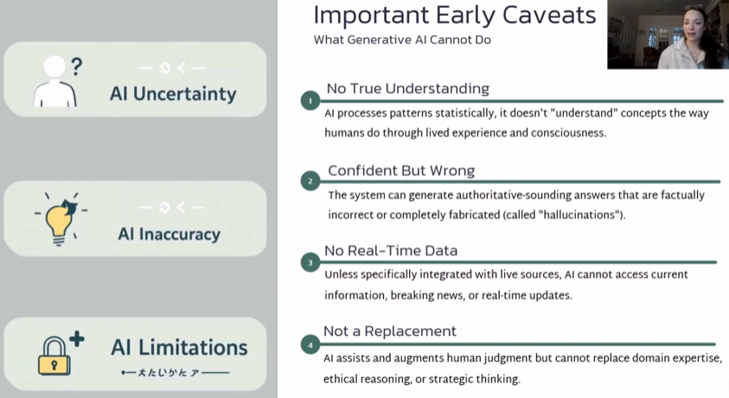
These limitations make it important to have a human in the loop
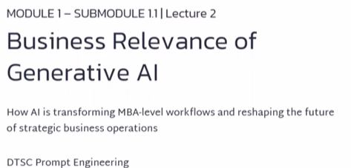
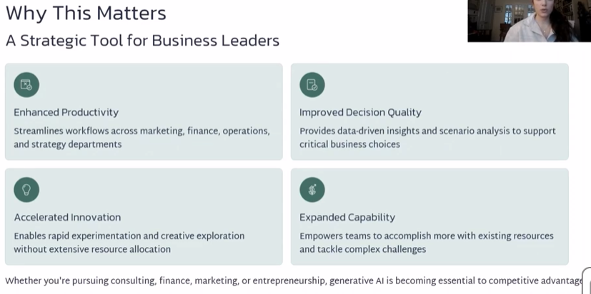
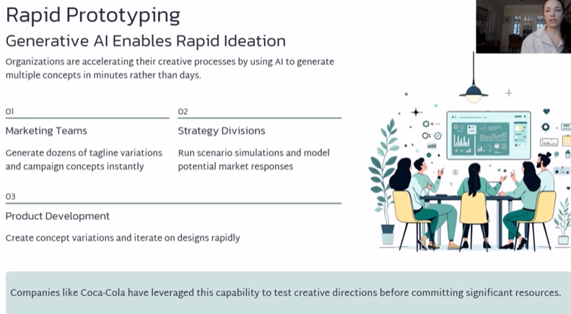
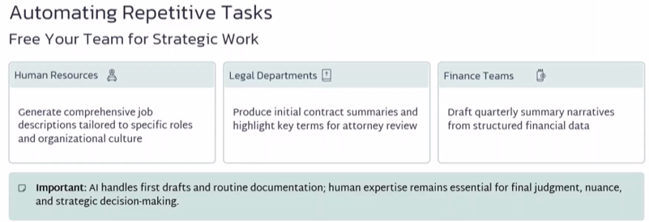
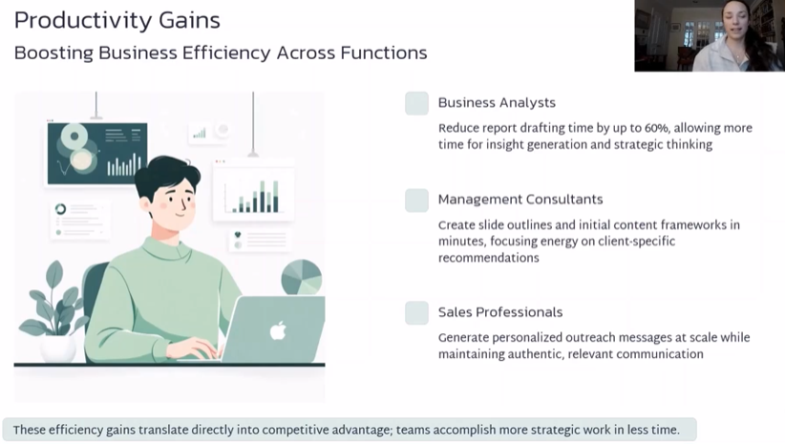
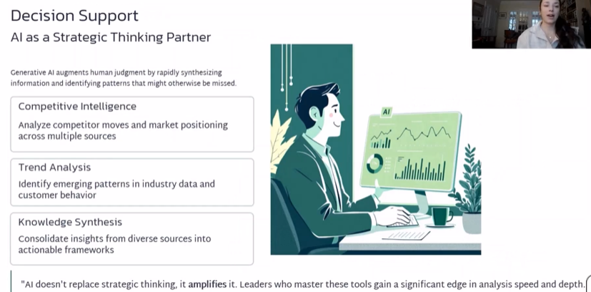
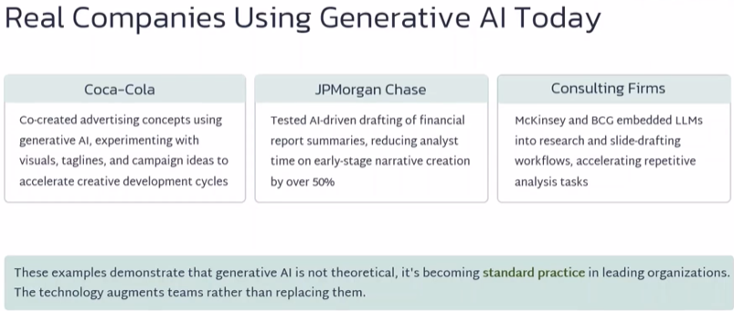

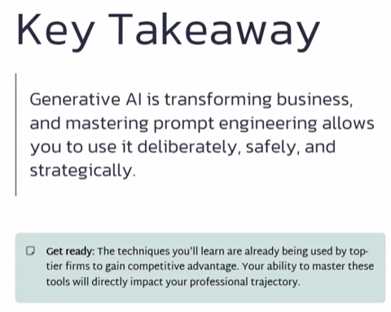

Examples of LLM
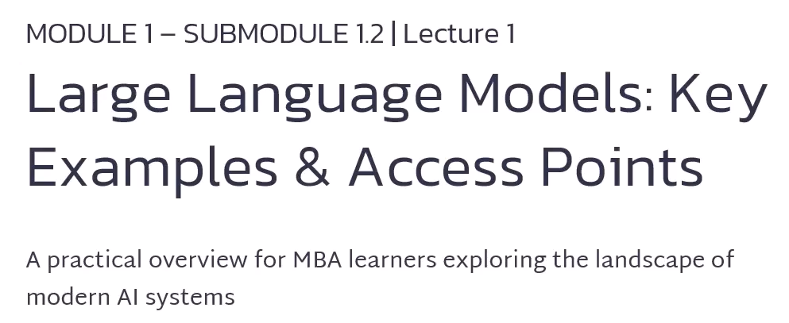
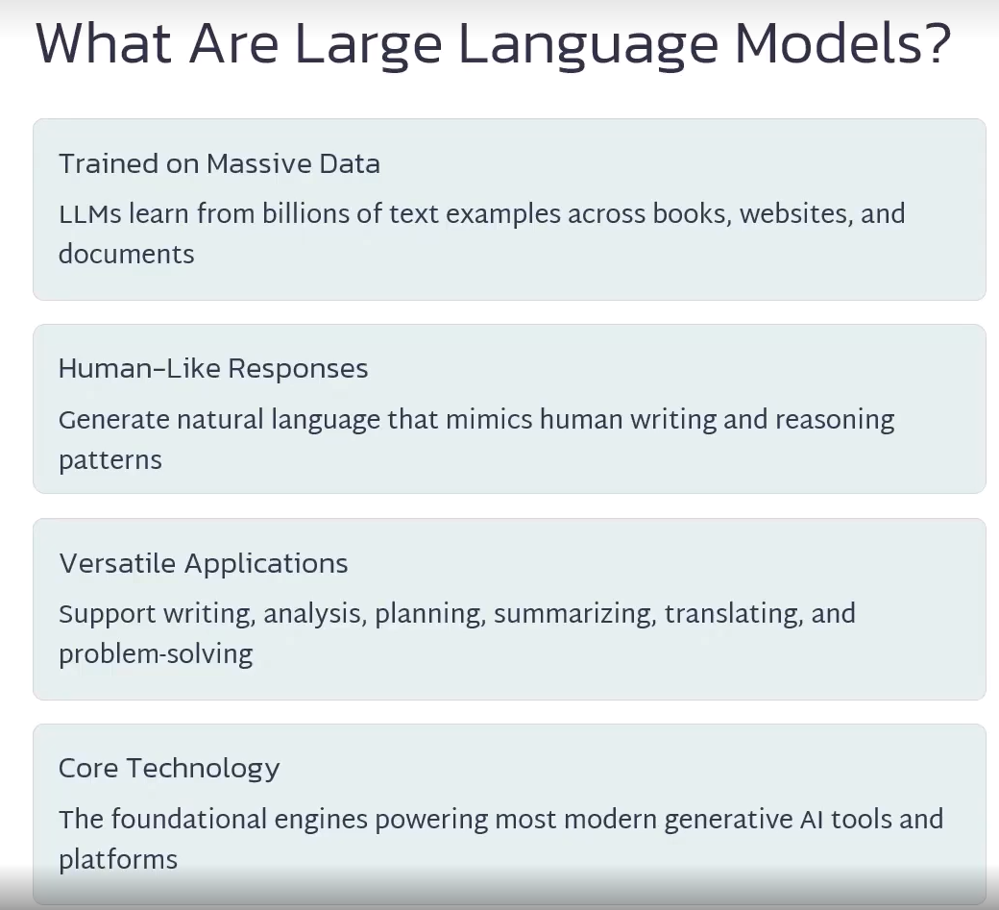
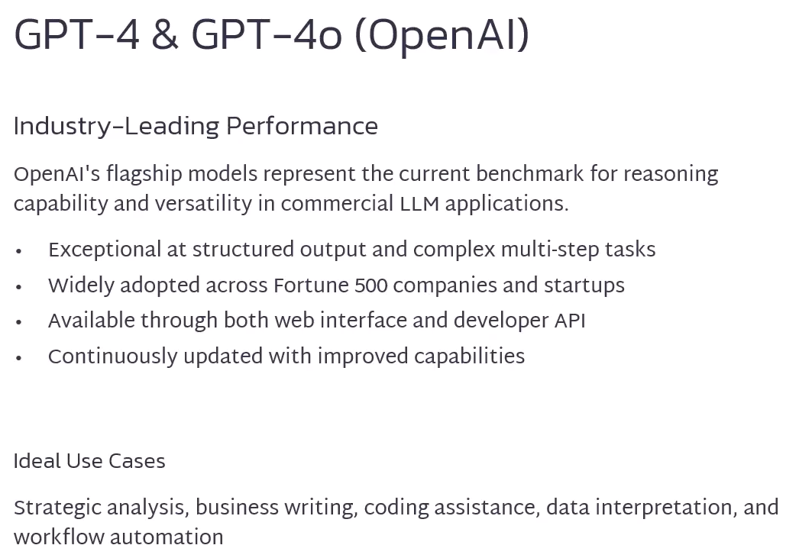
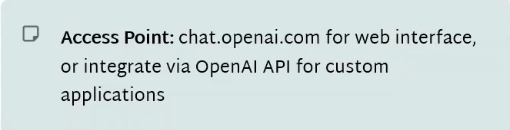
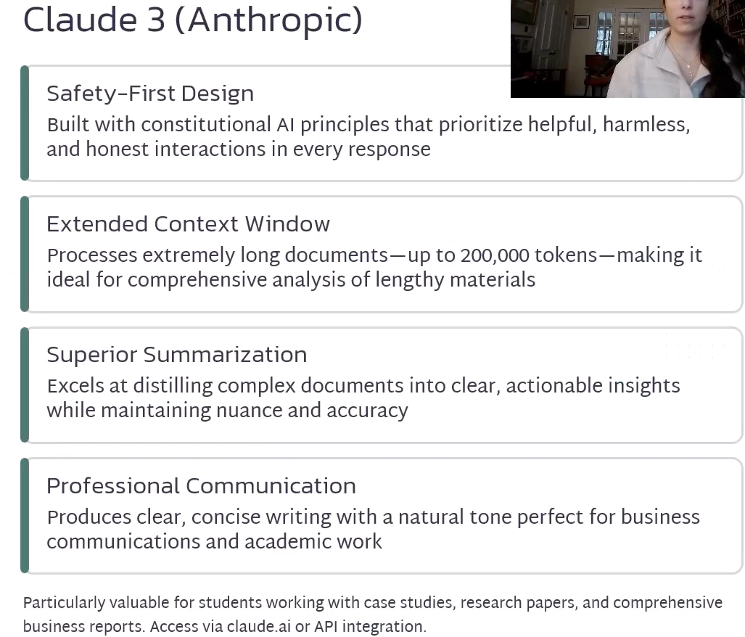
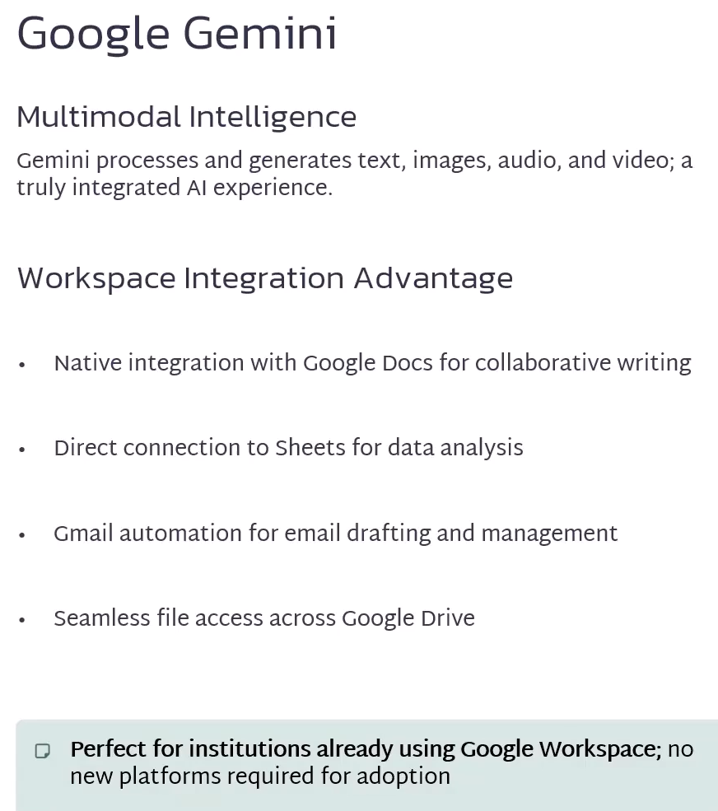
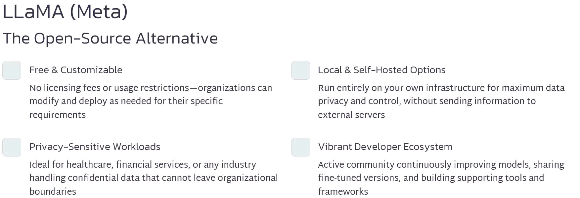
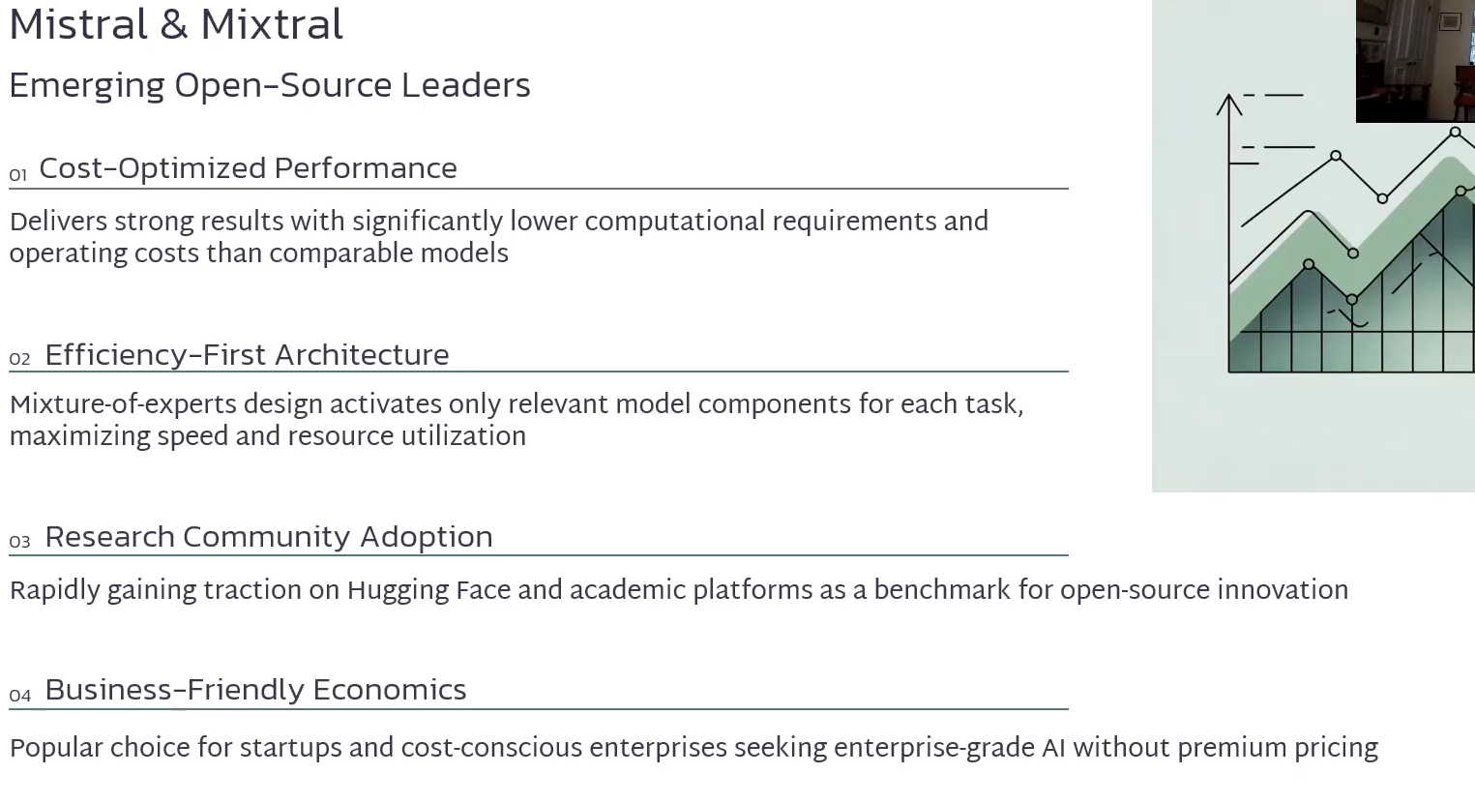
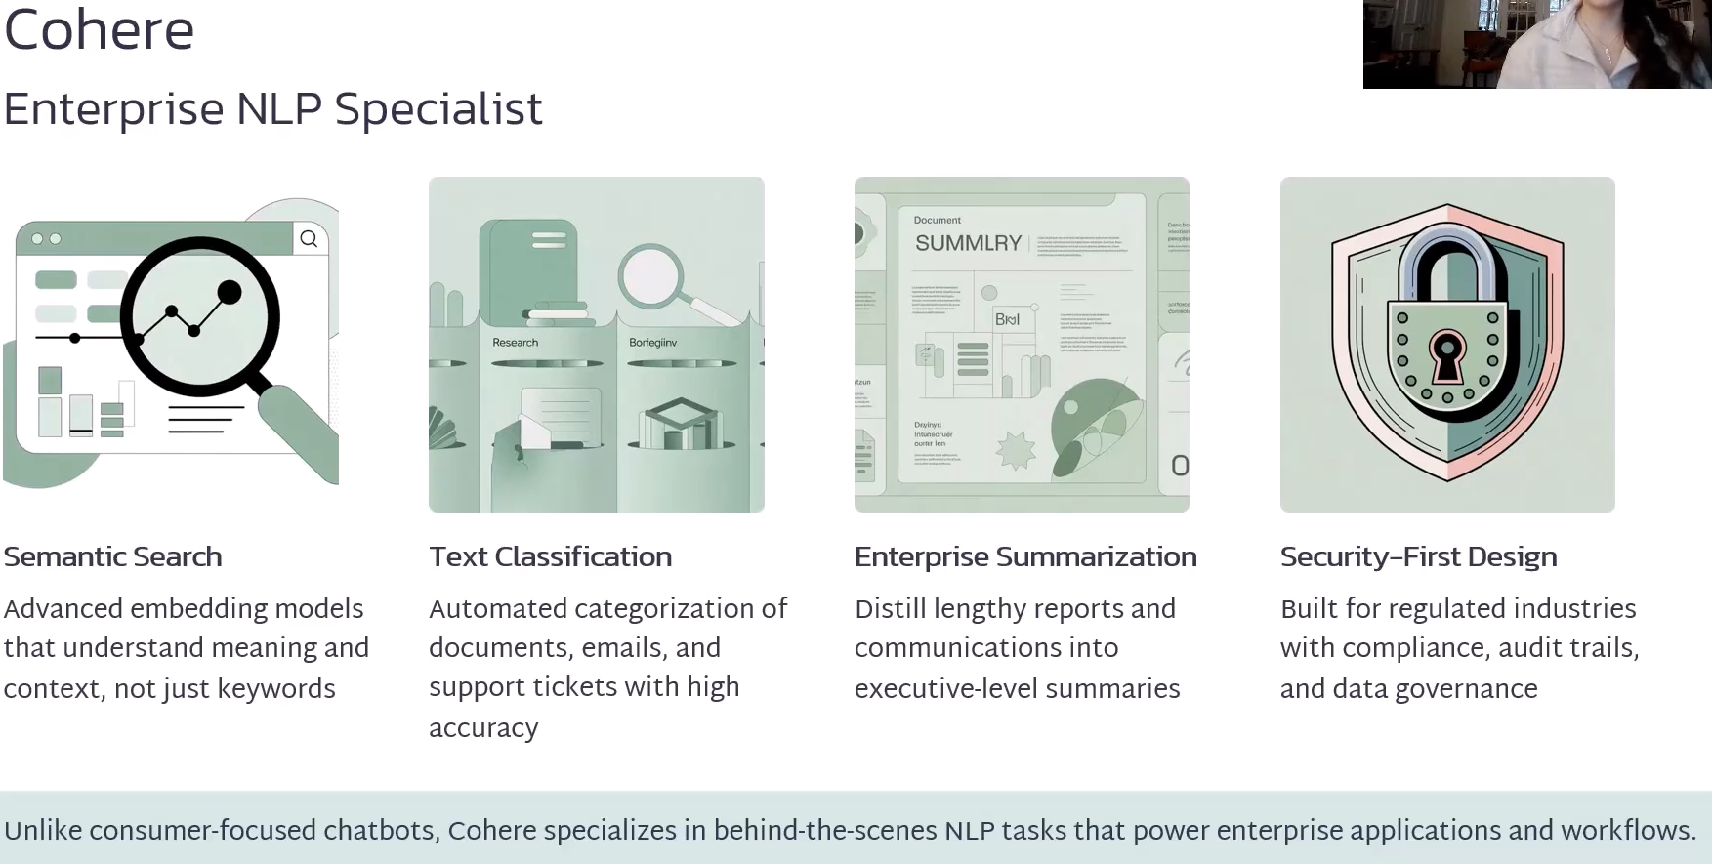
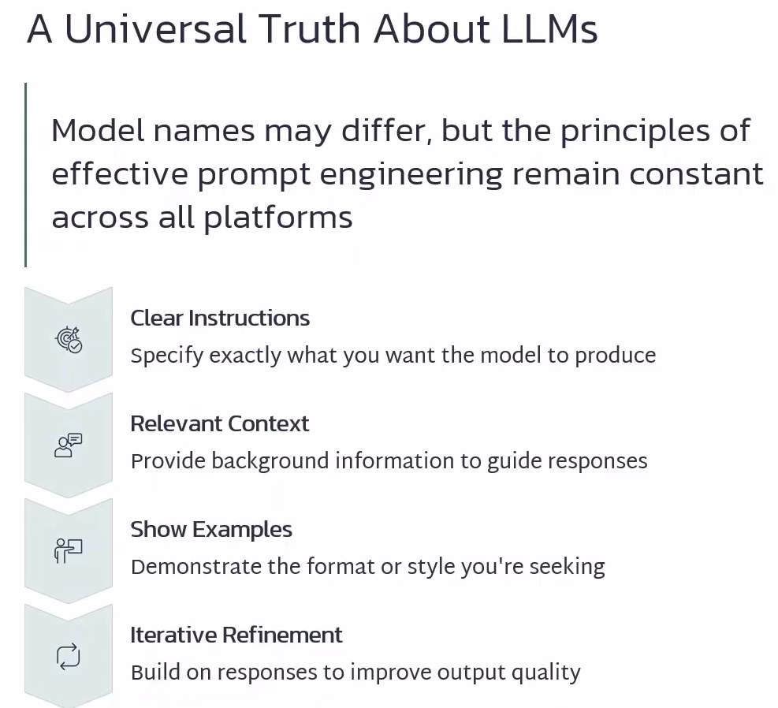
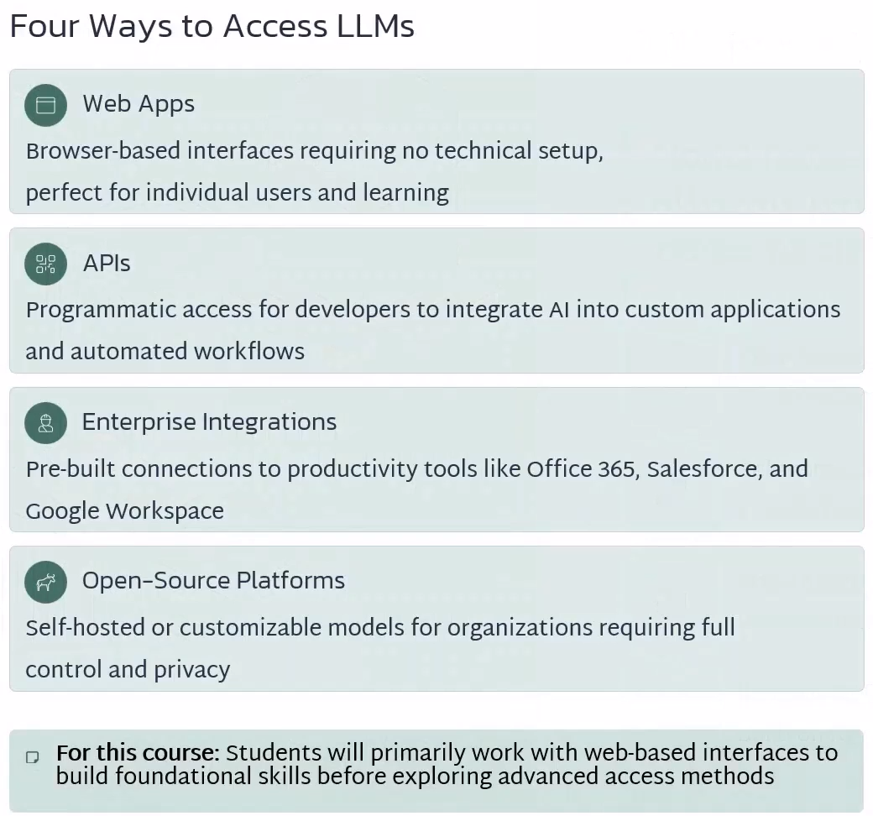
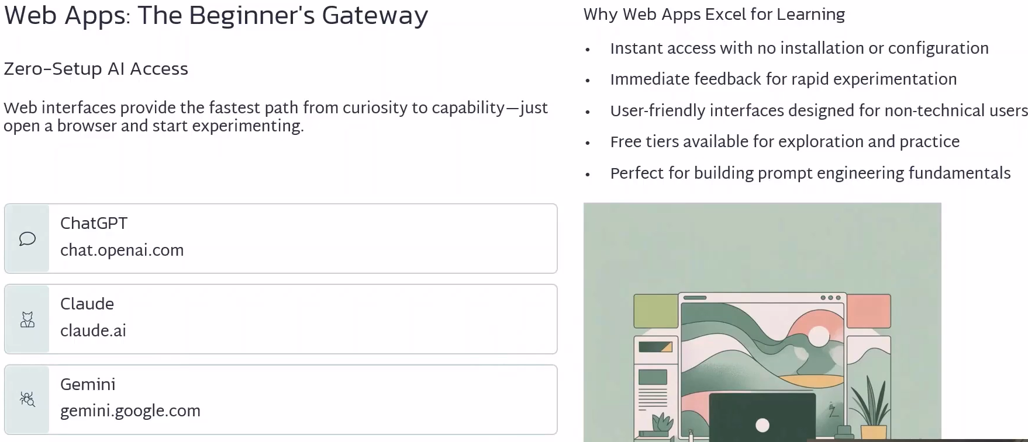
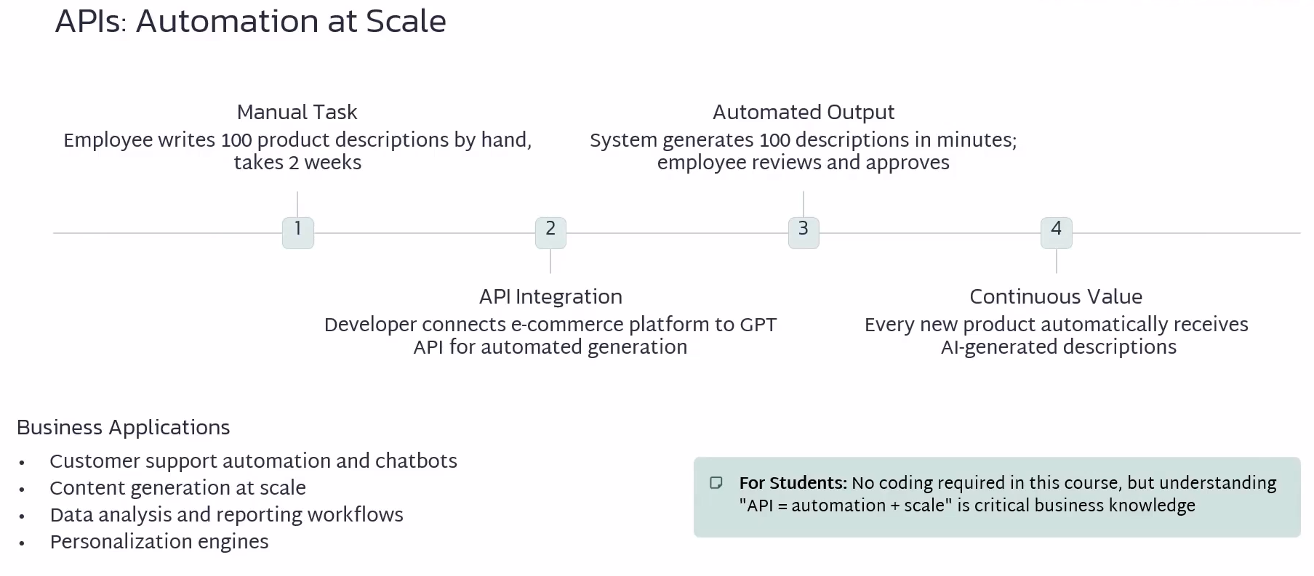
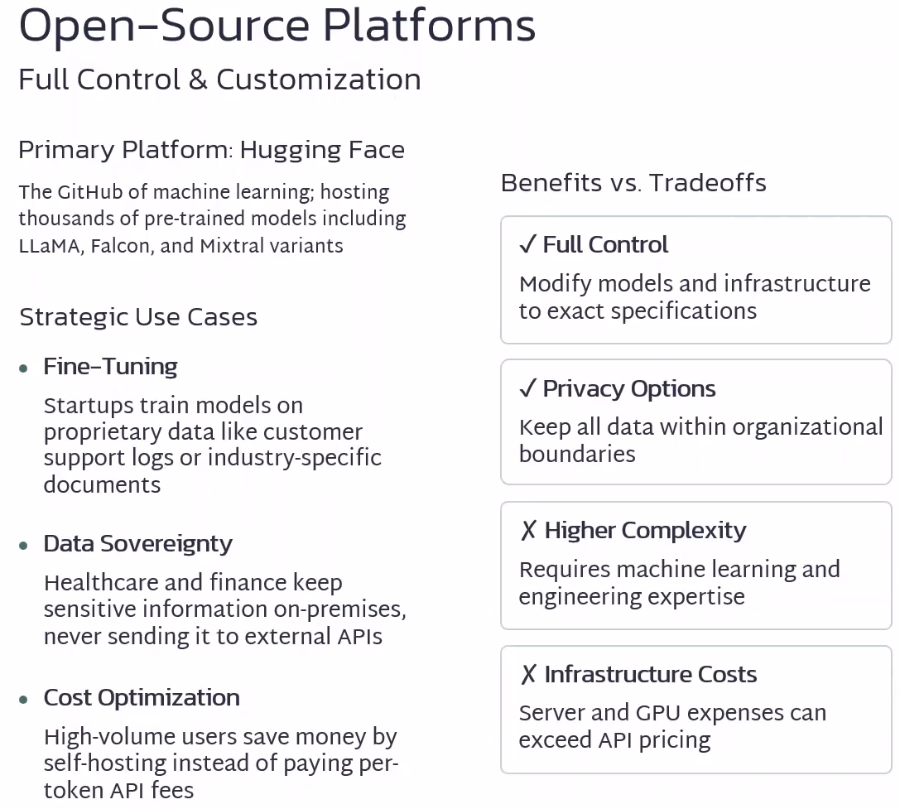
HuggingFace is the GitHub of machine learning
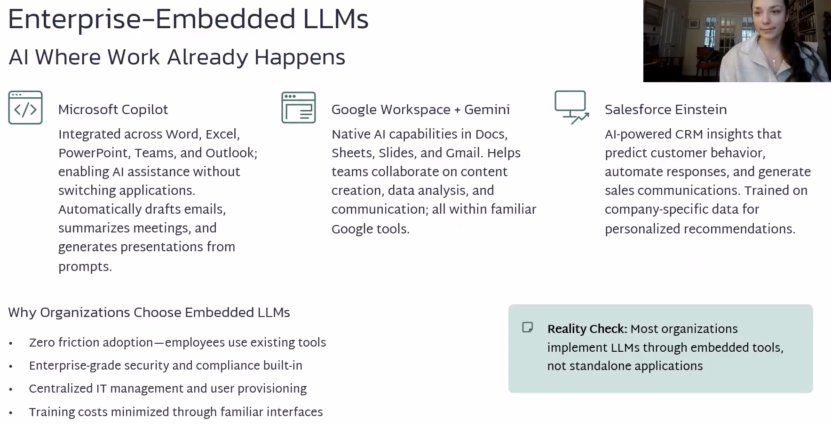
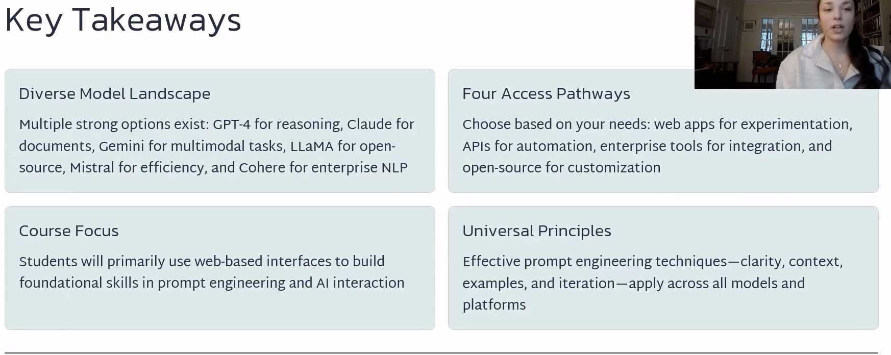`
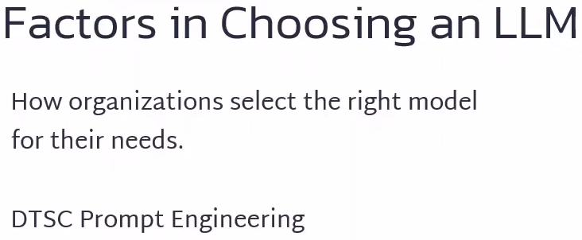
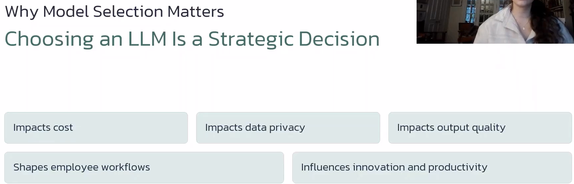
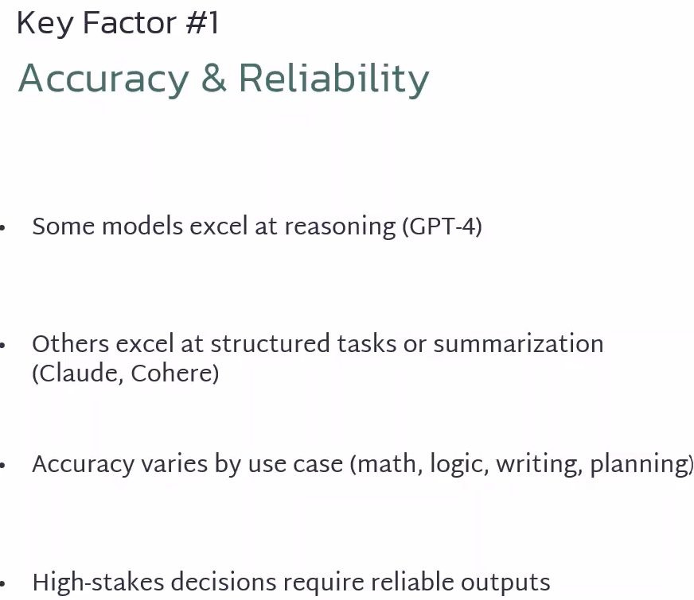
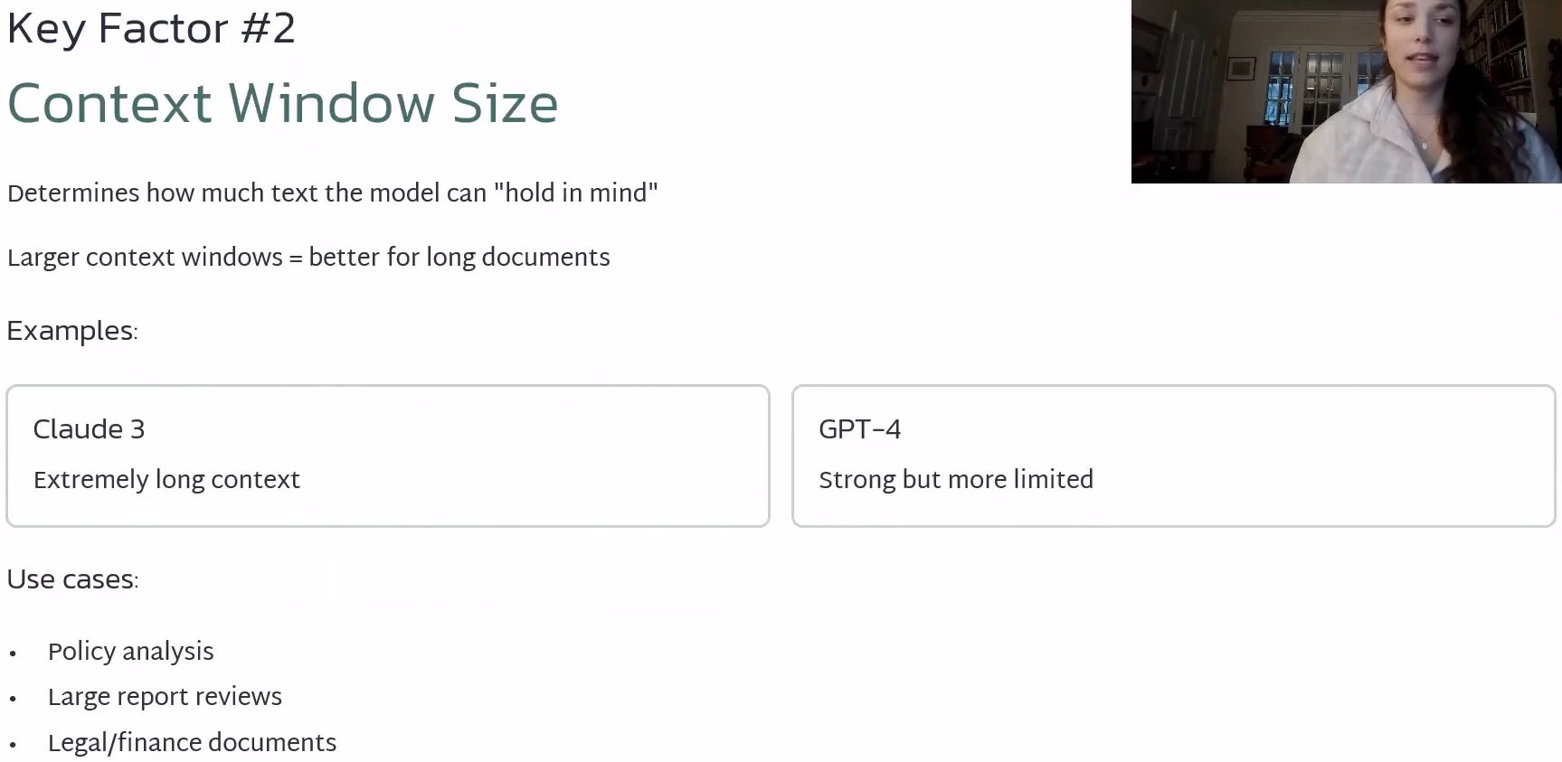

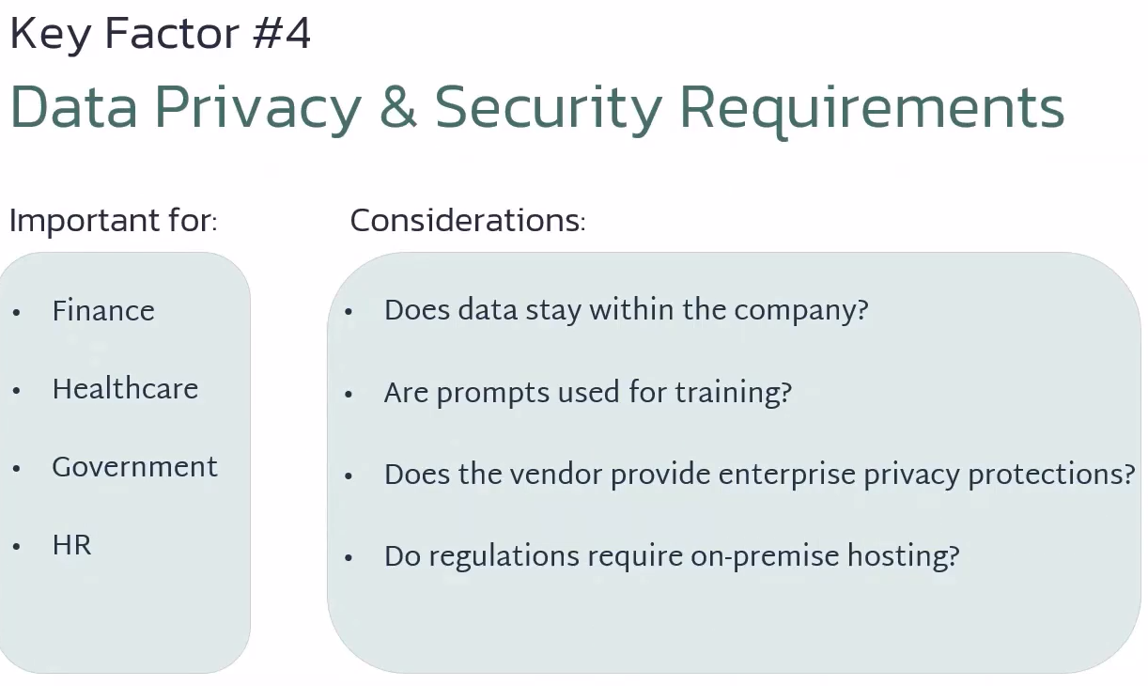
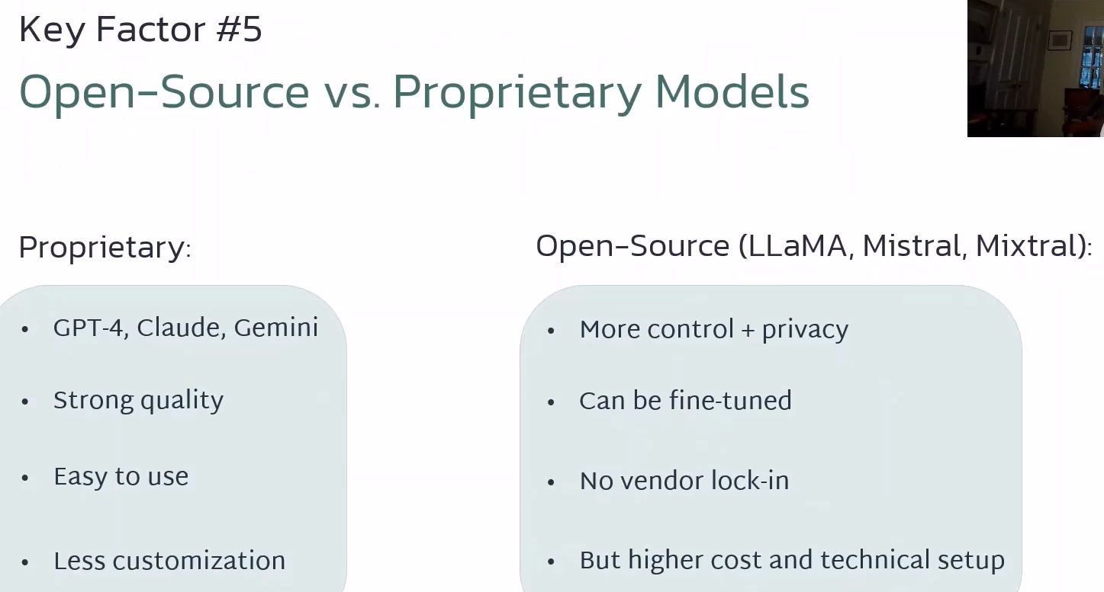
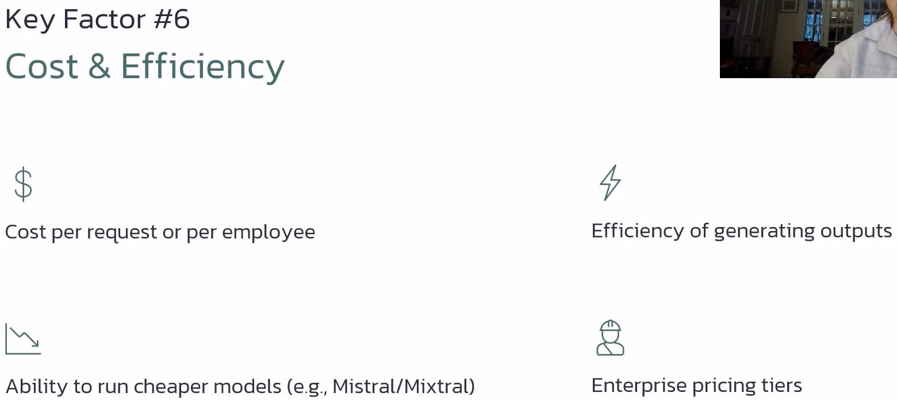
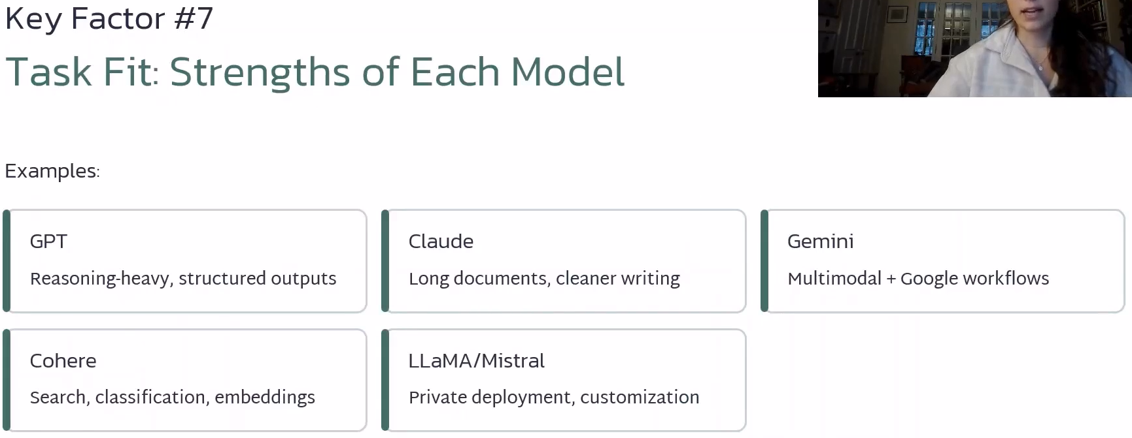
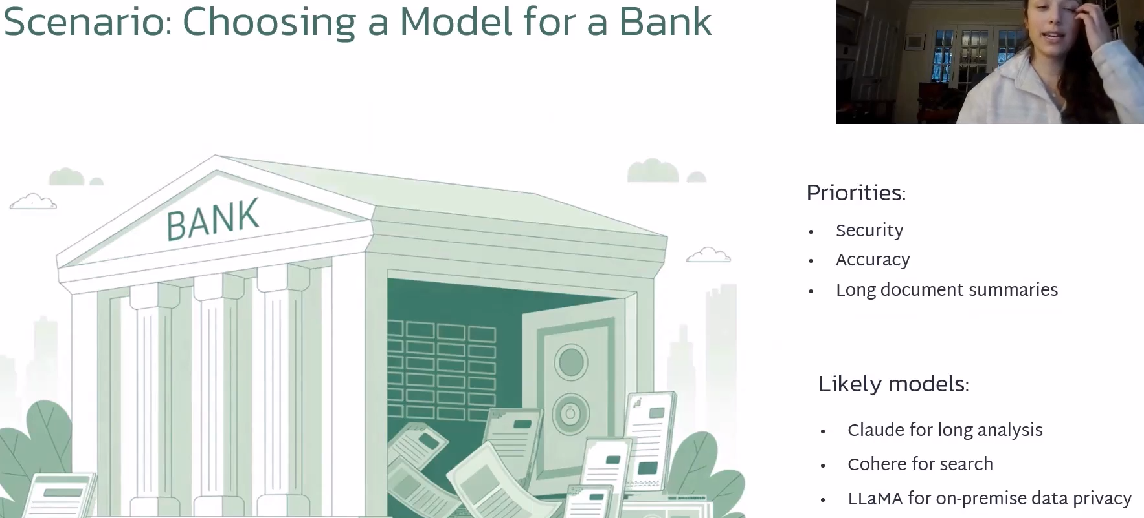

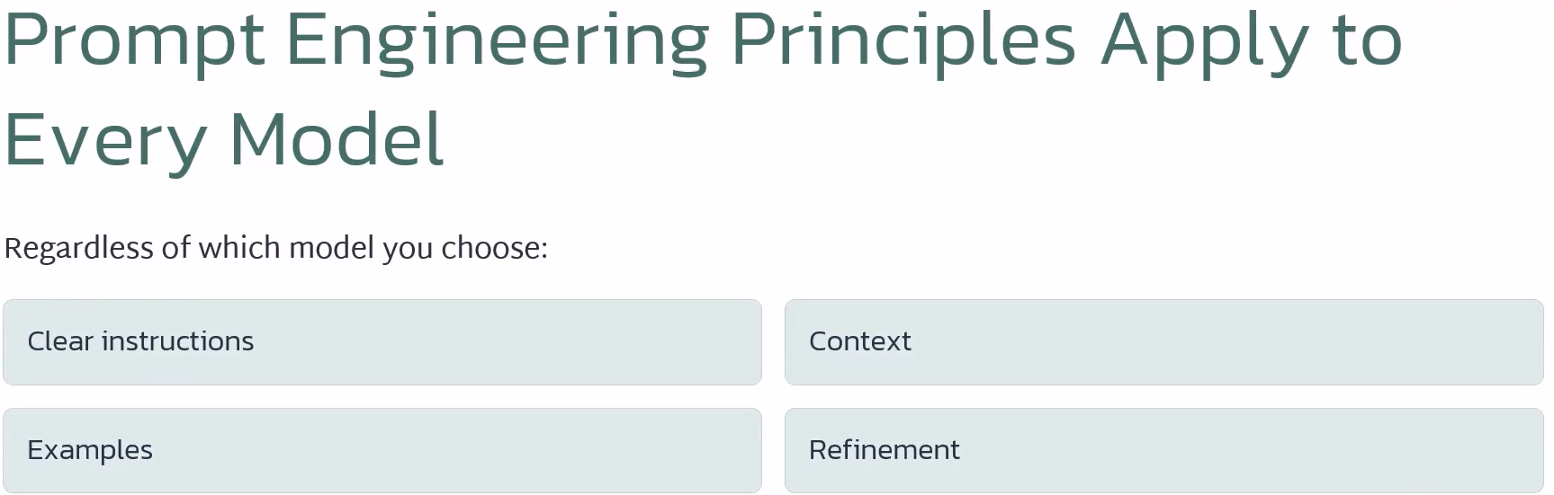

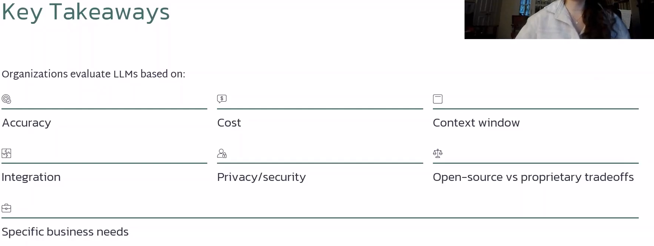

ChatGPT Summary of https://www.kaggle.com/whitepaper-prompt-engineering
I reviewed the linked Kaggle Prompt Engineering whitepaper and supporting material from its author. The core message is that prompt engineering is an iterative discipline for getting more reliable, useful output from large language models, not simply a matter of asking better questions.
Key takeaways
Prompt engineering shapes model behavior. The model, its configuration, wording, structure, context, style, and tone can all affect the response. Effective prompting therefore involves experimentation and refinement rather than expecting the first prompt to be optimal.
Model settings matter alongside the prompt. The paper discusses parameters such as temperature, Top-K, Top-P, and output length. These influence how the model selects tokens and how deterministic or varied its responses can be. This directly relates to your earlier question about temperature.
There are multiple prompting strategies. It covers techniques including zero-shot, one-shot/few-shot, system prompting, role prompting, contextual prompting, step-back prompting, Chain of Thought, self-consistency, Tree of Thoughts, and ReAct. Different techniques are appropriate for different types of problems.
Examples can substantially clarify intent. One-shot and few-shot prompting give the model examples of the desired behavior or output pattern. This is particularly useful when you need a predictable structure or classification behavior.
Good prompts should be clear and specific. The paper's best practices include providing examples, keeping prompts simple, giving explicit output instructions, controlling token length, using variables, experimenting with formats and writing styles, and documenting prompt experiments.
Prompt engineering is model-dependent. A prompt may need to be optimized for the particular model being used. The paper specifically discusses Gemini, while also recognizing models such as GPT, Claude, Gemma, and LLaMA.
The guidance extends beyond ordinary text generation. It discusses prompting for code generation, explanation, translation, debugging/review, as well as multimodal prompting.
The practical lesson
For someone using generative AI in a technical or business setting, I would condense the paper to this principle:
Tell the model what you want, give it the context it needs, show it what good looks like when appropriate, specify the expected output, and iteratively test the result.
One particularly relevant point given our preceding conversation: temperature is only one variable. The whitepaper makes clear that model configuration and prompt design work together. Consequently, audience, context, examples, output requirements, and model parameters can all affect the answer you receive.

What is Prompt Engineering


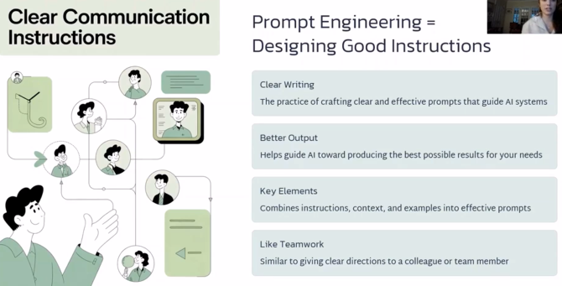
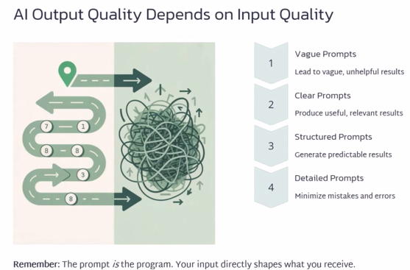
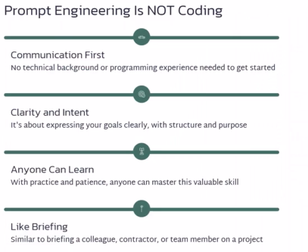
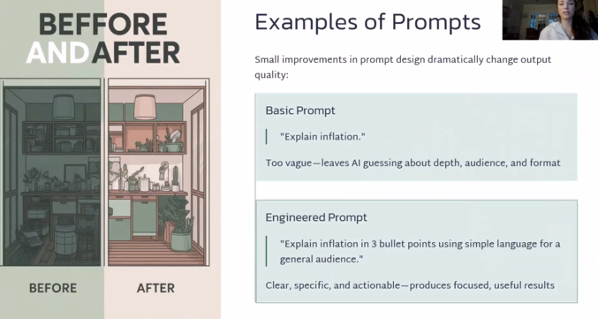
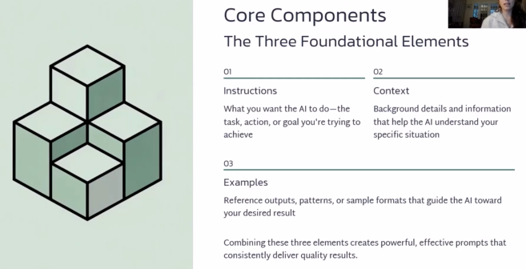
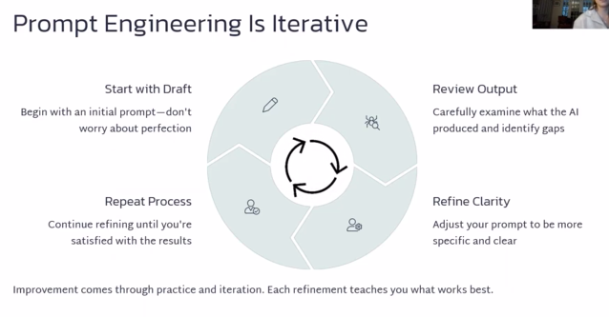
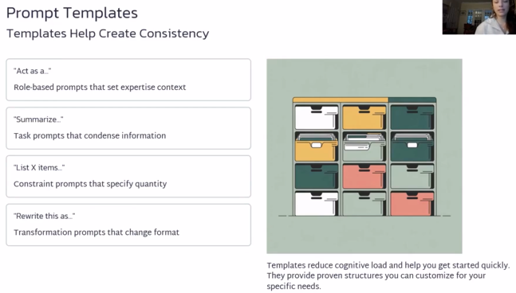
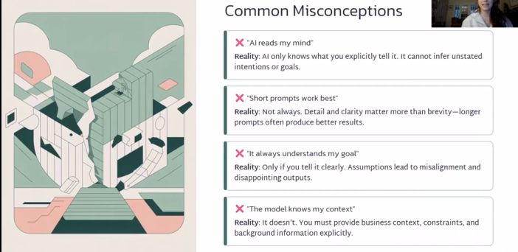
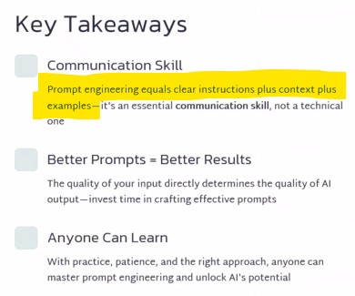
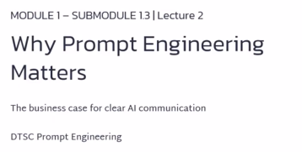
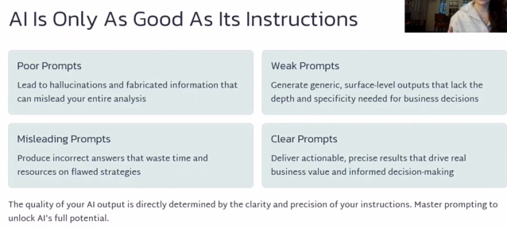
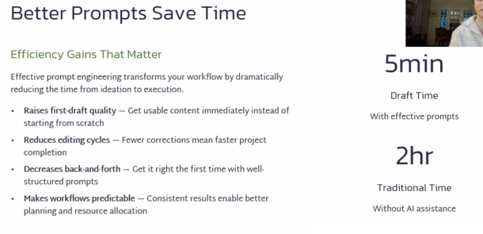
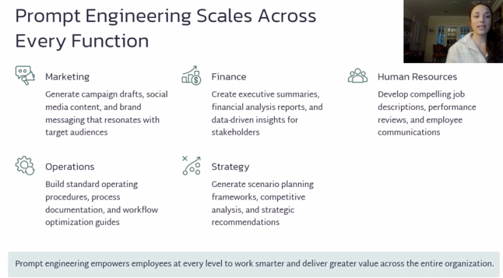
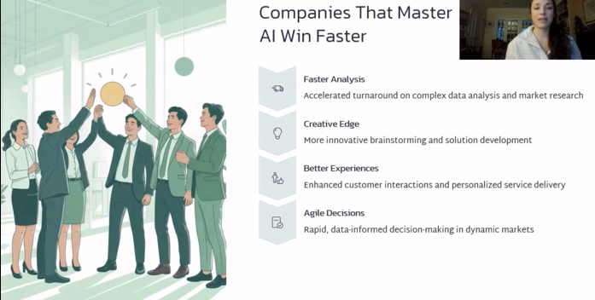
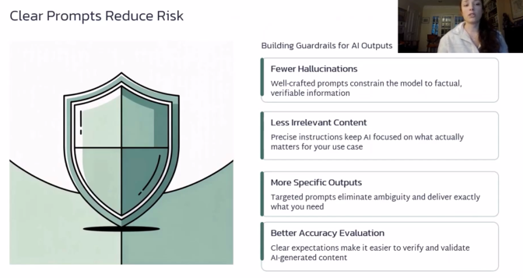
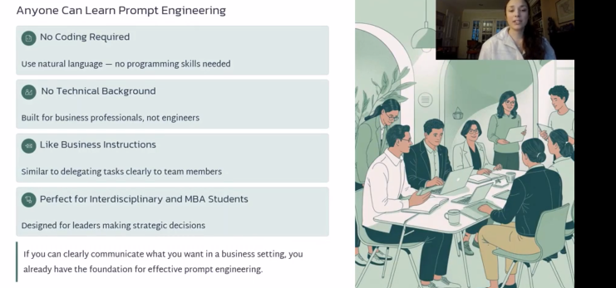
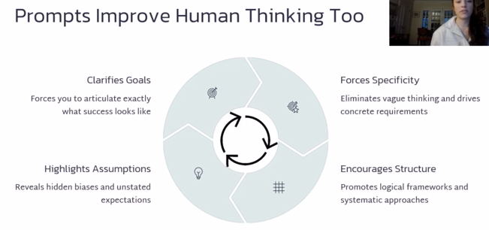
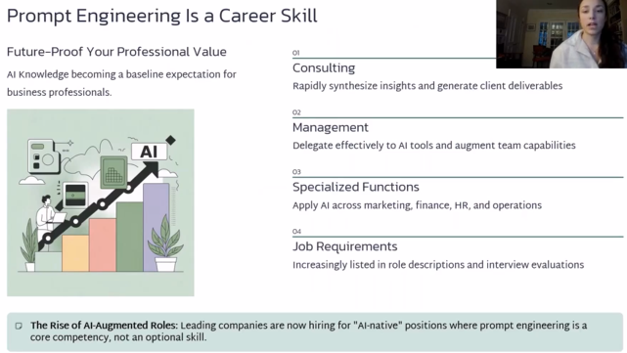
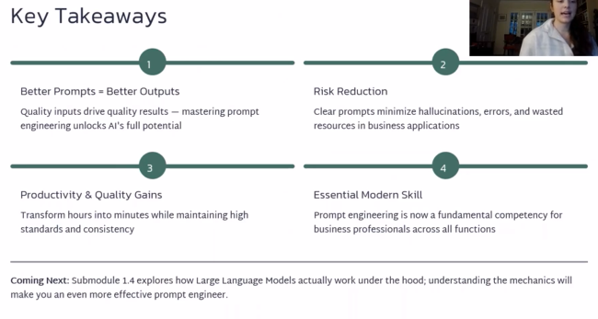

How LLMs work
https://www.youtube.com/watch?v=LPZh9BOjkQs
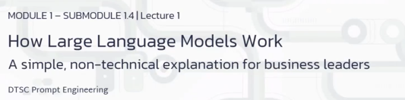
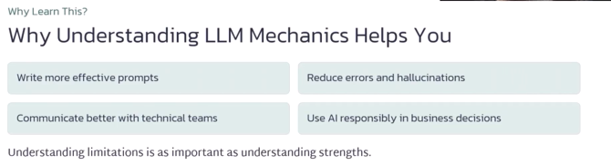
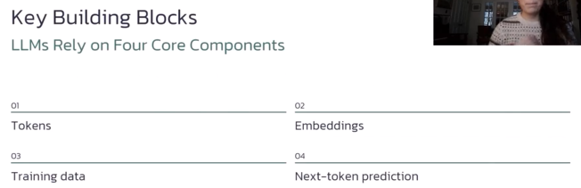
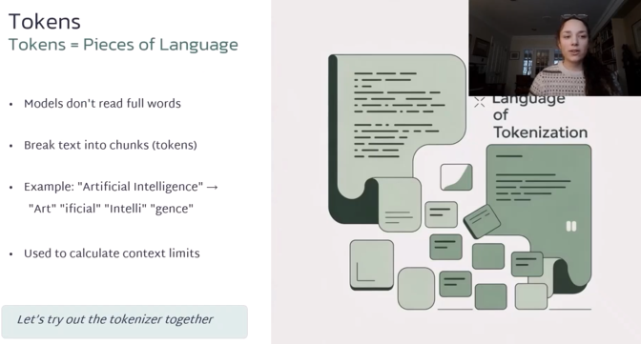
https://platform.openai.com/tokenizer


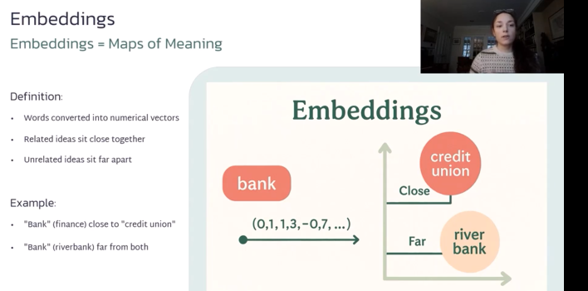
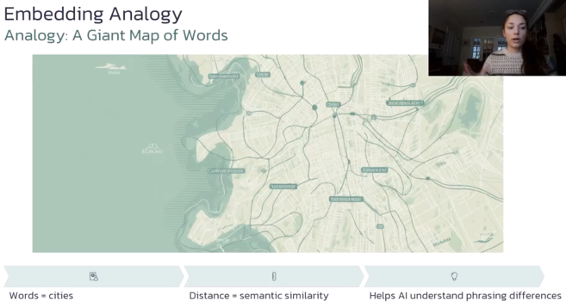
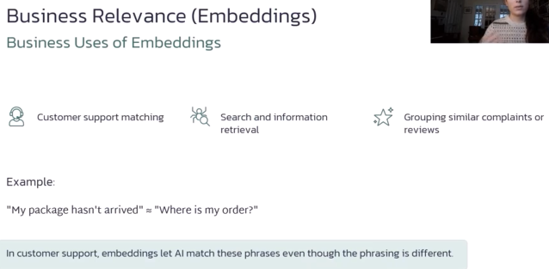
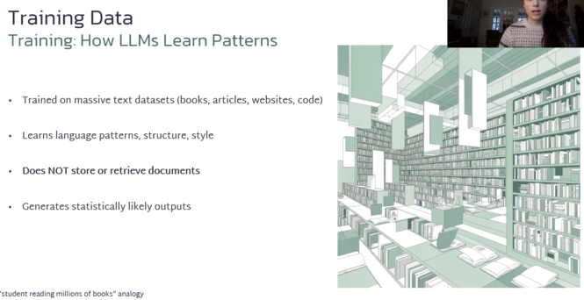


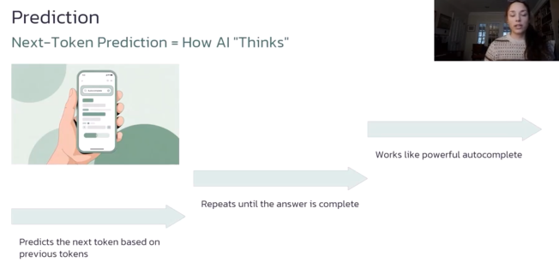
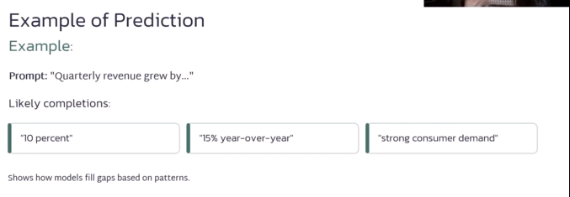
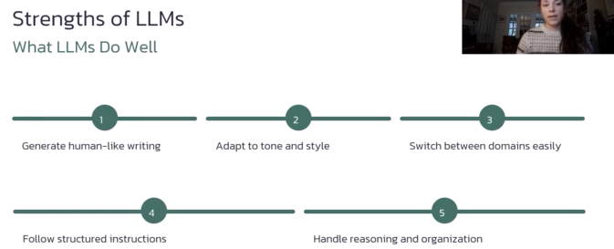
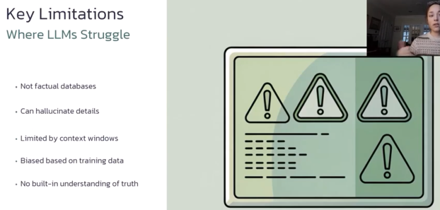
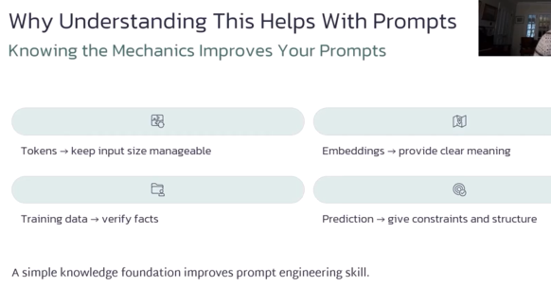
View
In this activity, you will explore how word and sentence embeddings work by visualizing them in a 3D interactive space. The Embedding Projector allows you to examine relationships between words, see which concepts cluster together, and understand how LLMs capture semantic meaning through vector distance. This hands-on tool reinforces the Module 1 content on embeddings by letting you experiment with similarity, clustering, and dimensionality reduction in a dynamic, intuitive way.
https://projector.tensorflow.org/


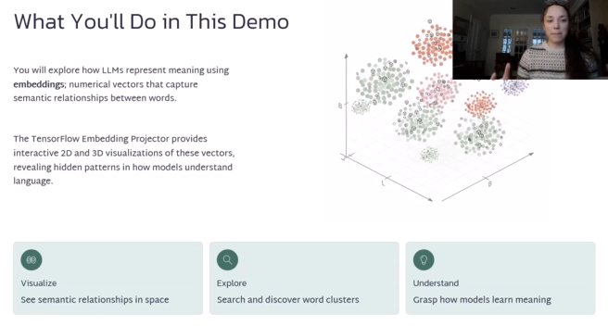
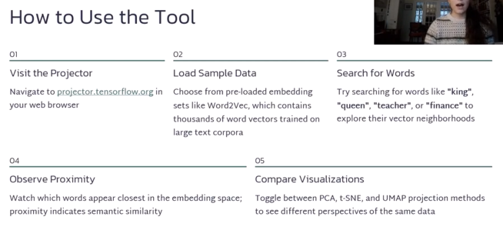
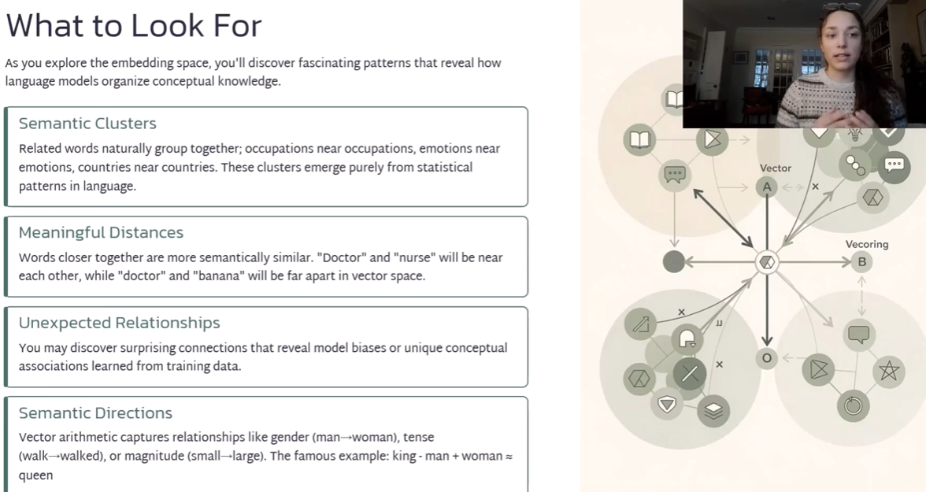

https://cohere.com/llmu/sentence-word-embeddings?_sm_nck=1
Gemini Summary
The article "What Are Word and Sentence Embeddings?" by Luis Serrano (published in Cohere's LLM University) explains how computers process human language by converting text into numerical representations called embeddings.
Key Takeaways
- Bridging Text and Numbers: Computers cannot process raw words or sentences directly; they only process numbers. An embedding converts words or sentences into list coordinates (vectors) so machine learning models can process them.
- Word Embeddings Capture Meaning and Relationships:
  - Words with similar meanings or contexts are located closer together in vector space (e.g., apple and banana are close, while apple and bicycle are farther apart).
  - Beyond similarity, word embeddings capture sub-relationships and semantic properties—such as size, age, or gender—allowing arithmetic operations across word concepts (e.g., $Puppy-Dog+Cow≈Calf$).
- Sentence Embeddings Beyond Word Sums: Simply adding up individual word vectors fails to capture sentence structure and meaning (e.g., "I am no good" vs. "No, I am good!"). Modern sentence embedding models convert full sentences into single vectors that capture full context and semantics, mapping phrases with similar meanings together even if they share no identical words (e.g., "Hello, how are you?" and "Hey what's up").
- Multilingual Embeddings: Sentence embeddings can be trained to be language-agnostic. Phrases expressing the same concept in English, French, or Spanish map to nearby coordinates, enabling cross-lingual search and translation.
For a quick visual breakdown of how word vectors work in practice, check out Vectoring Words (Word Embeddings) - Computerphile. This video provides a clear explanation of how word vectors represent linguistic context and numerical relationships.
https://www.youtube.com/watch?v=gQddtTdmG_8
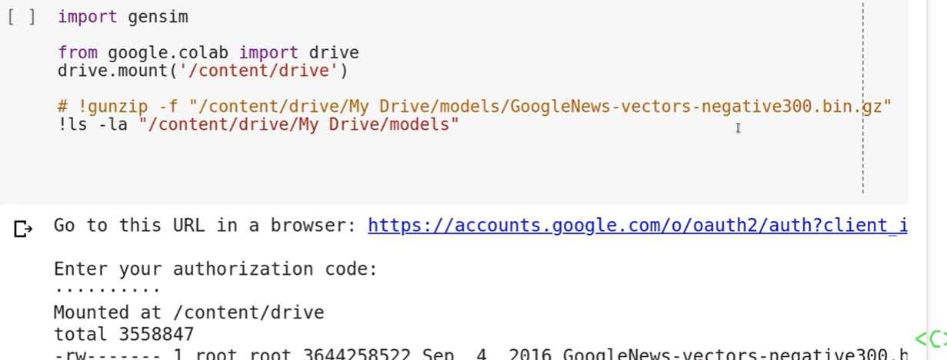
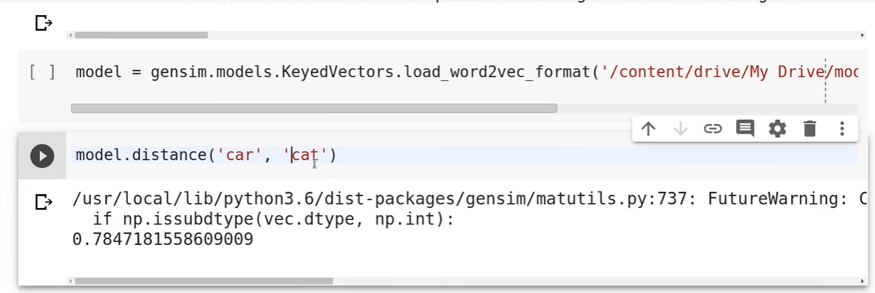
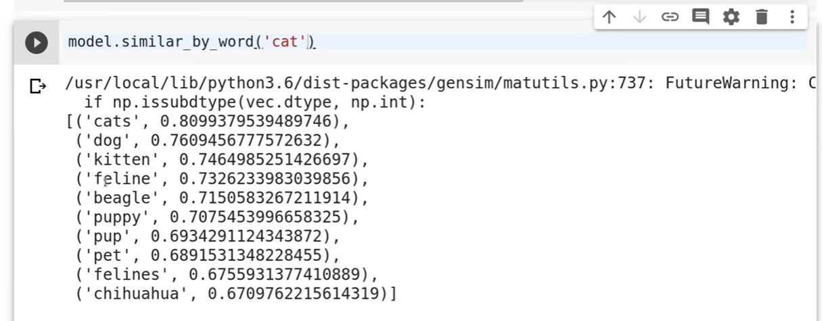
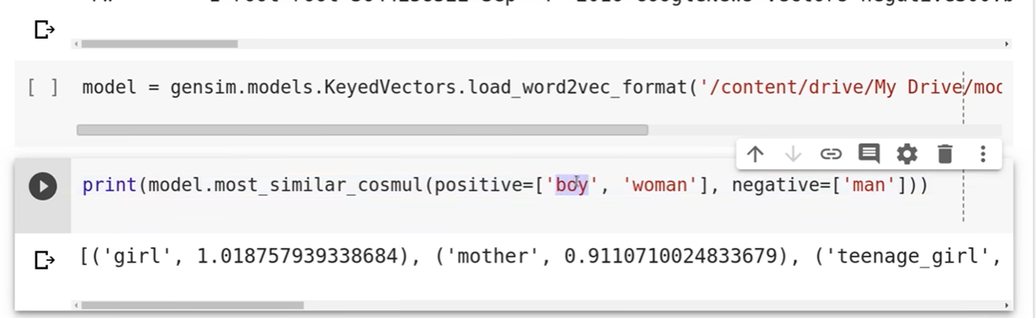
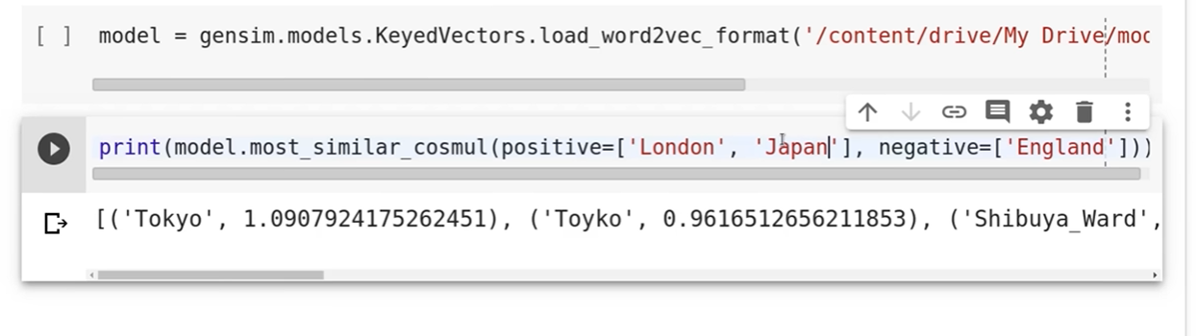
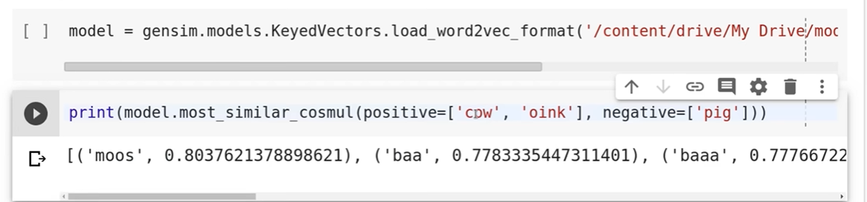
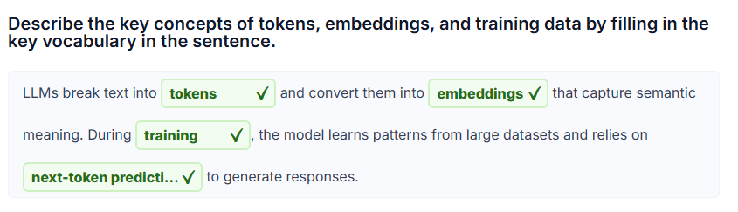
LLMs break text into tokens and convert them into embeddings that capture semantic meaning. During training the model learns patterns from large datasets and relies on next-token prediction to generate responses.
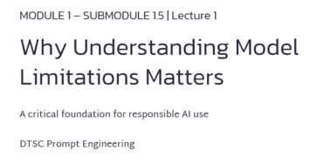
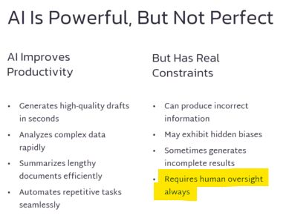
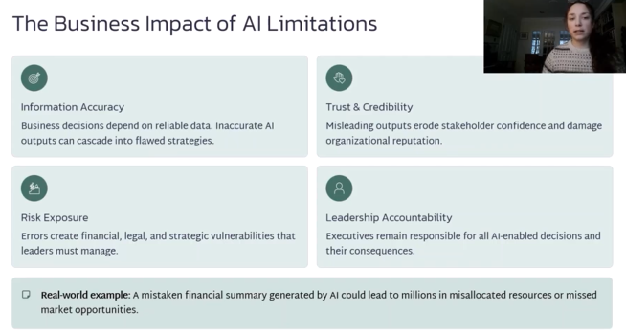
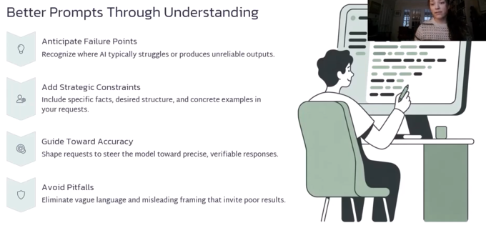
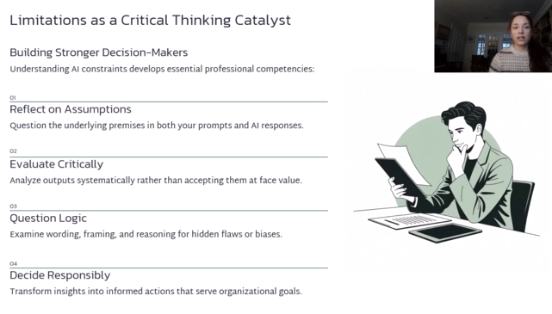
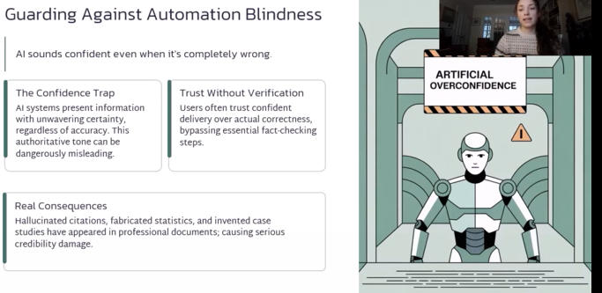
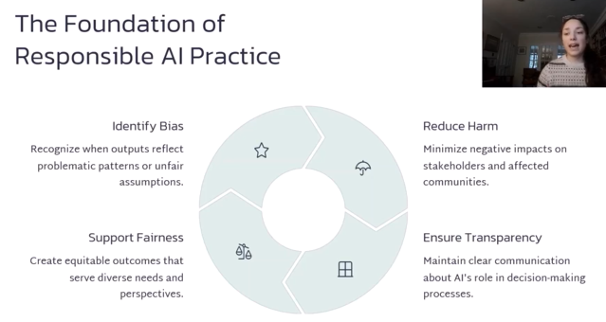
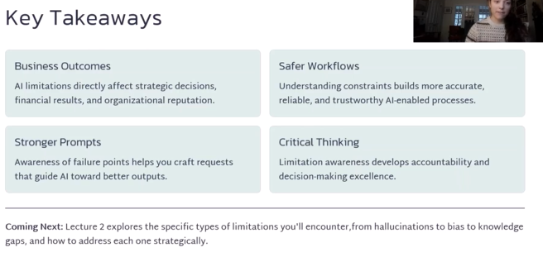


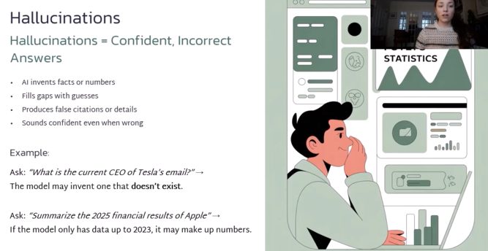
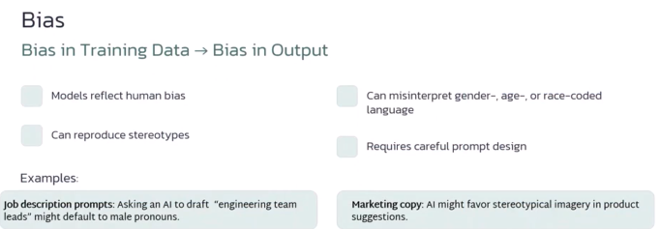


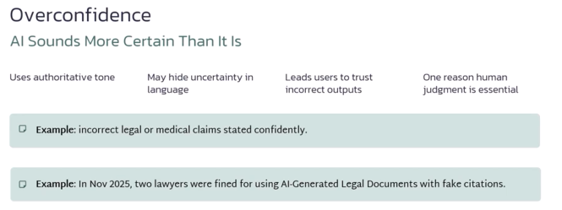
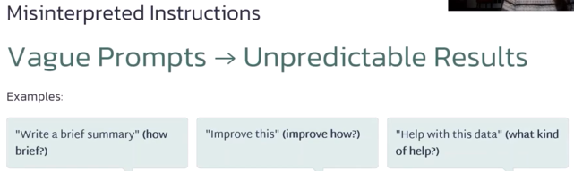

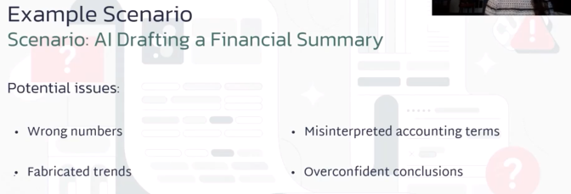
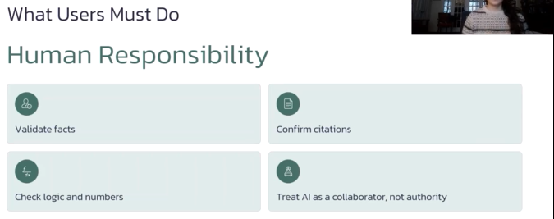
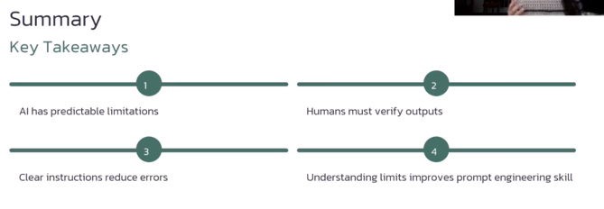
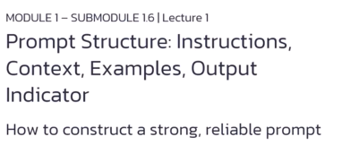
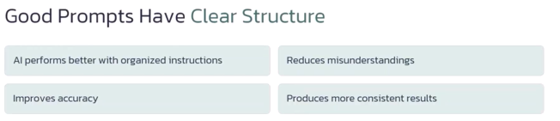
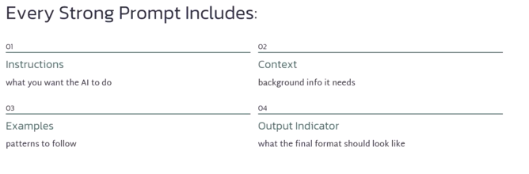
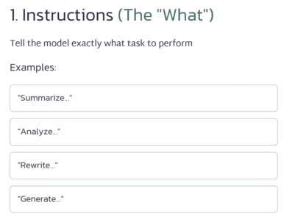
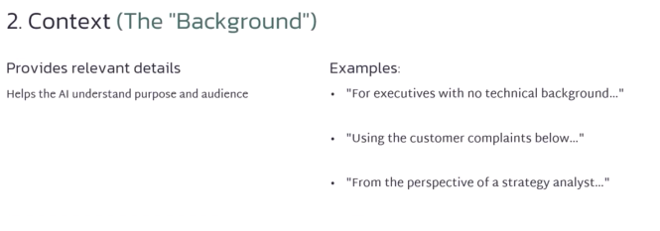
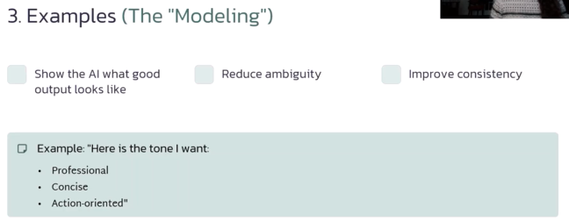
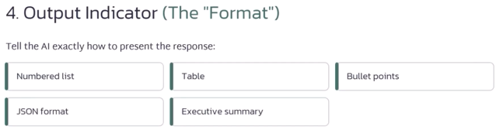
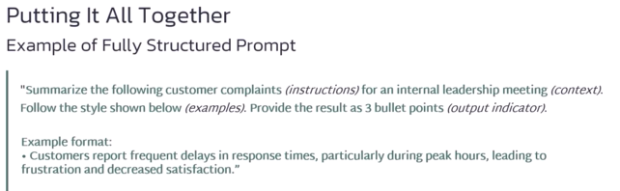
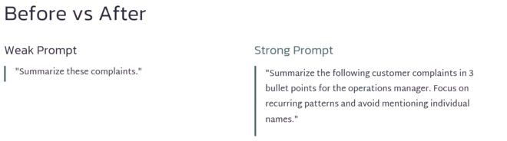
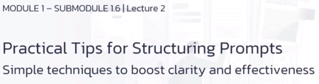
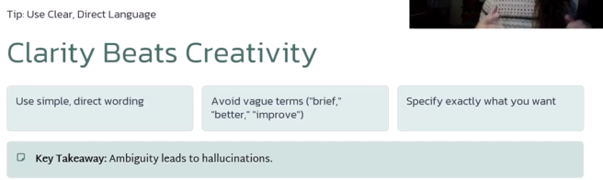
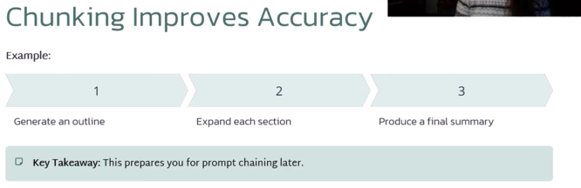
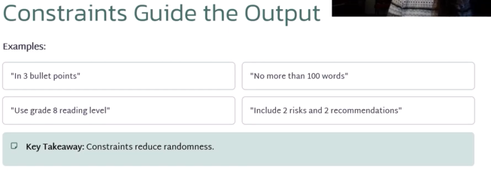
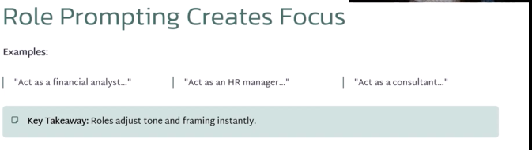
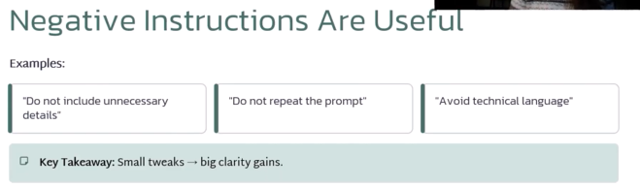
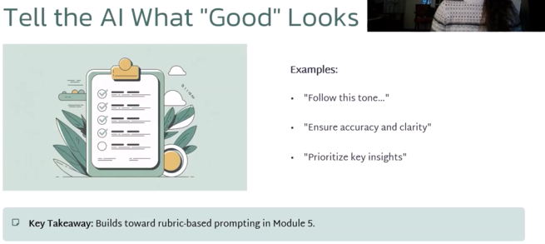

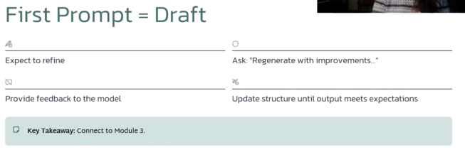
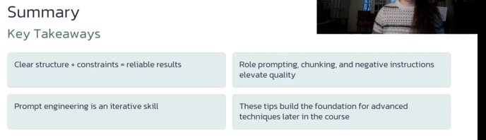
A well-structured prompt includes clear instructions, relevant context and helpful examples.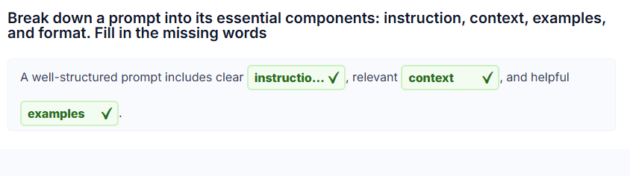 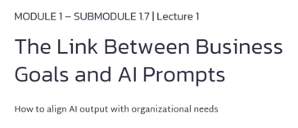
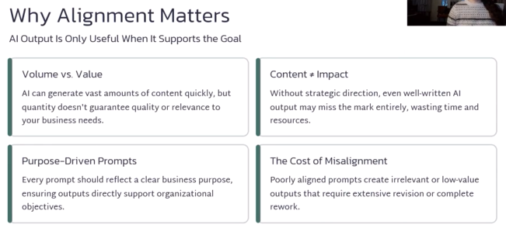
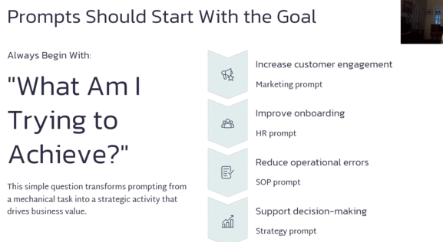
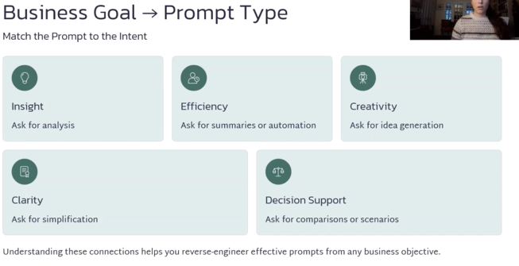
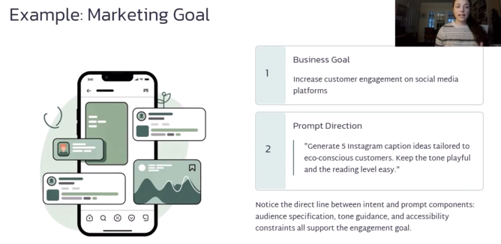
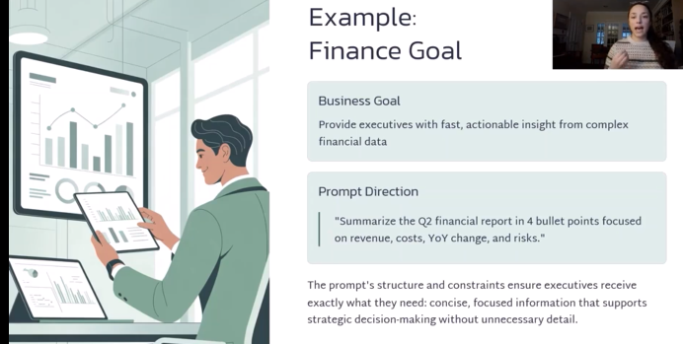
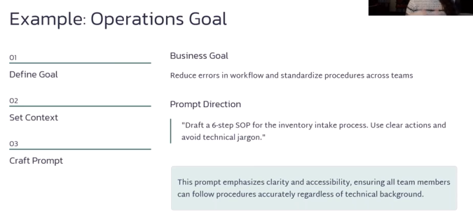
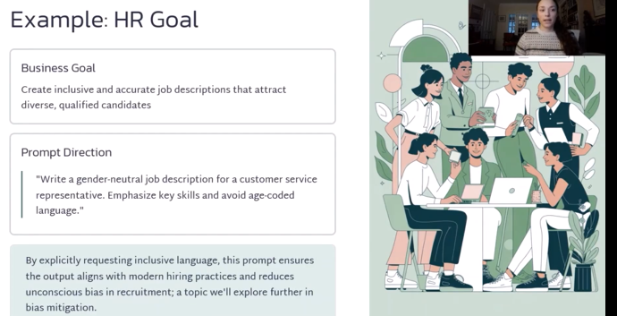
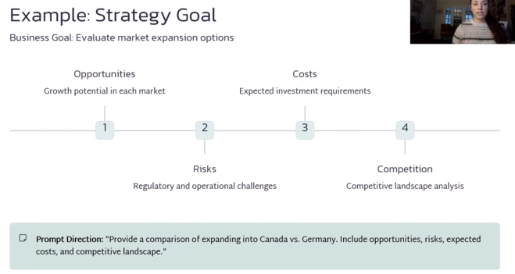
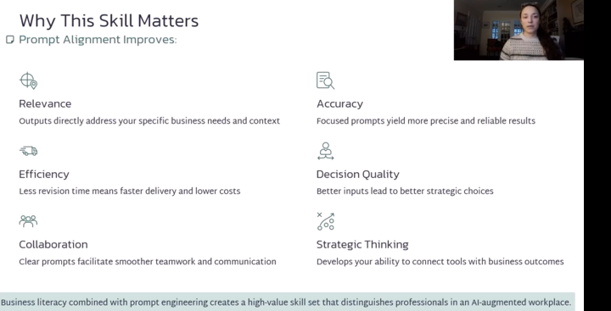
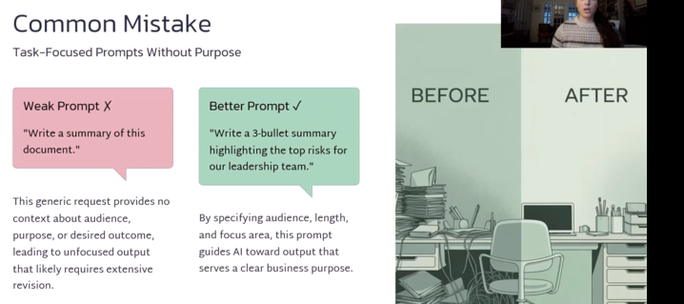
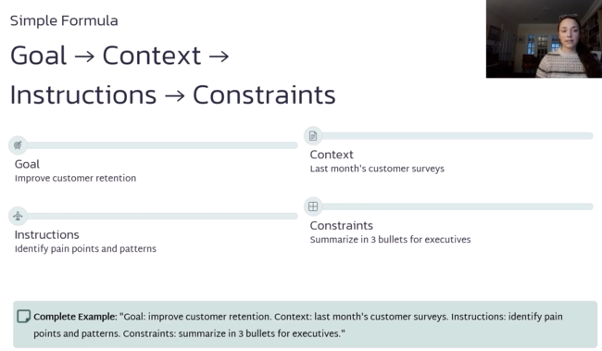
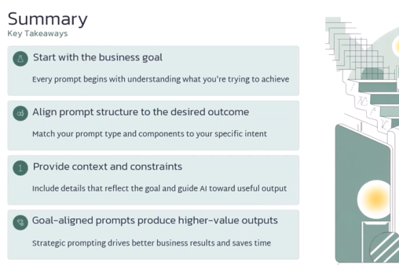

Summary of https://www.ibm.com/think/insights/generative-ai-business-value

Summary of Exploring generative AI to maximize experiences, decision-making and business value
The IBM Think article argues that generative AI creates business value primarily by augmenting existing enterprise AI and business processes, rather than simply replacing people or reducing costs. [ibm.com]
Key points:
- Four major capabilities: IBM identifies summarization, semantic search, content creation, and code creation as areas where generative AI can significantly enhance existing processes. Examples range from summarizing financial reports and customer interactions to generating documentation, test cases, infrastructure scripts, and application code. [ibm.com]
- Business value goes beyond cost savings: Potential benefits include improved employee satisfaction, greater customer trust, business growth, faster insights into customer complaints, more efficient internal audits, and improvements in testing and classification. [ibm.com]
- Generative AI introduces meaningful risks: IBM highlights bias, lack of transparency, hallucinations, intellectual-property concerns, and security threats such as prompt injection. [ibm.com]
- Governance is essential: Organizations need strong AI ethics and governance mechanisms to understand and mitigate these risks instead of treating generative AI as a conventional technology deployment. [ibm.com]
- Start with lower-risk use cases: IBM recommends initially prioritizing internal, employee-facing applications where humans review AI-generated output and very high precision is not required. [ibm.com]
Bottom line: The article's central message is that generative AI can produce real business value by improving existing processes and decision-making, but organizations should balance that opportunity with human oversight, risk assessment, and strong AI governance. [ibm.com]
For your AI governance work, the most relevant part is IBM's argument that business value and AI risk should be considered together when deciding which use cases to deploy, rather than adopting generative AI simply because the technology is available.

